Cameroon

## Political Stability Estimate Data

The data set shows the political stability estimate of the country each year.

## # A tibble: 19 x 5  
## country iso3c date stability stabilityCategory4   
## <chr> <chr> <dbl> <dbl> <chr>   
## 1 Cameroon CMR 1996 -0.957 moderately unstable  
## 2 Cameroon CMR 1998 -0.782 moderately unstable  
## 3 Cameroon CMR 2000 -0.563 moderately unstable  
## 4 Cameroon CMR 2002 -0.677 moderately unstable  
## 5 Cameroon CMR 2003 -0.430 moderately unstable  
## 6 Cameroon CMR 2004 -0.360 moderately unstable  
## 7 Cameroon CMR 2005 -0.183 moderately unstable  
## 8 Cameroon CMR 2006 -0.245 moderately unstable  
## 9 Cameroon CMR 2007 -0.325 moderately unstable  
## 10 Cameroon CMR 2008 -0.551 moderately unstable  
## 11 Cameroon CMR 2009 -0.474 moderately unstable  
## 12 Cameroon CMR 2010 -0.737 moderately unstable  
## 13 Cameroon CMR 2011 -0.662 moderately unstable  
## 14 Cameroon CMR 2012 -0.589 moderately unstable  
## 15 Cameroon CMR 2013 -0.532 moderately unstable  
## 16 Cameroon CMR 2014 -1.06 highly unstable   
## 17 Cameroon CMR 2015 -0.990 moderately unstable  
## 18 Cameroon CMR 2016 -1.06 highly unstable   
## 19 Cameroon CMR 2017 -1.08 highly unstable

## Political Stability Estimate Plot

The plot shows the trends of stabilization and destabilization for the each country.

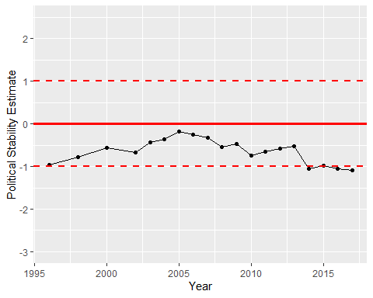

Political Stability Trend